Order management
Avram Andrei-Alexandru
30424

- Assignment’s objective
The main objective of this assignment is to design and implement an application that is capable of performing some operations on the data and with the data from a database. These operations are: inserting and removing a client from the database, inserting and deleting a product from the database, placing client orders and generating PDF reports for clients, products and orders. As for secondary objectives, two of them could be identified: the design of a relational SQL database to hold the data the application requires to function and the design and implementation of a command parser to identify the commands our application needs to perform.
The input for the order management application is supplied in the form of a text file given as an argument to the application. The format of this text file is presented below. This is just an example; any combination of these commands can be passed to the program provided they follow the exact format presented below.
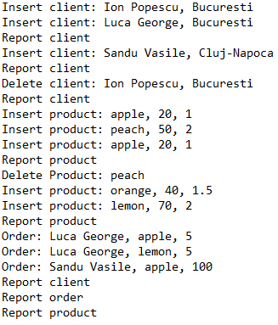
Next, I will explain briefly what these commands do.
1. Insert client: Ion Popescu, Bucuresti: Will insert into the database a new client having the first name Ion, last name Popescu and the address Bucuresti.
2. Report client/order/product: Will generate PDF reports for clients/orders/products.
3. Delete client: Ion Popescu, Bucuresti: Removes from the database the client having the first name Ion, last name Popescu and the address Bucuresti.
4. Insert product: apple, 20, 1: Will insert a new product having the name apple, the quantity 20 and the price 1.
5. Delete product: peach: Will remove from the database the product having the name peach.
6. Order: Luca George, apple, 5: Will place an order for Luca George for a quantity of 5 for the product named apple.

- Problem analysis, modelling, scenarios, use-cases

The possible use-cases are presented in the drawing below:

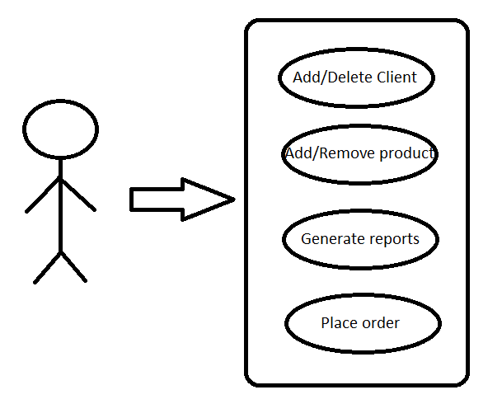
First use-case: Add/Delete Client.
- Success scenario:
  - The command for the insert/delete client is read and parsed successfully.
  - The new client is inserted in the database or in case of deletion is removed.
- Alternative scenario 1:
  - The command for the insert/delete client is wrong and an error message is displayed and the program function continues.
- Alternative scenario 2:
  - The command for the insert/delete client is read and parsed successfully.
  - The client already exists in the database so it will not be added again and an error message is displayed or in case of deletion the client is missing from the database so an error message is displayed.
Second use-case: Add/Remove product.
- Success scenario:
  - The command for the add/remove product is read and parsed successfully.
- The new product is inserted in the database or in case of deletion is removed
Alternative scenario 1:
  - The command for the add/remove product is wrong and an error message is displayed and the program function continues.
- Alternative scenario 2:
  - The command for the add/remove product is read and parsed successfully.
  - In case of deletion if the product does not exist in the database an error message is displayed and the program function continues.
Third use-case: Generate reports.
Success scenario:
  - The command for generate report and parsed successfully.
  - The PDF report is generated.
Alternative scenario 1:
  - The command for generating reports is wrong and an error message is displayed and the program function continues.
Alternative scenario 2:
  - The command for generate report and parsed successfully.
  - In the database no content is found corresponding to required data to be reported and an error message is displayed and the program function continues.
This application can have many real-world use-cases. For example, it can be used by a company that provides the option for clients to order some products from them. Also, the said company can use this application to generate reports to monitor sale performance or to make statistics.

Design (design decisions, UML diagrams, data structures, class design, interface, relations, packages, algorithms)
For the design of this application I have chosen to use five packages. These packages are explained briefly below:
- com.business package: Contains the classes that implement the application logic.
- com.data_access package: Contains the classes that implement the access to the database.
- com.model package: Contains the classes that represent the data models of the application.
- com.presentation package: Contains the classes that work on and with user input and output.
- com.start package: Contains the class with the main method.
Data structures used:
- Lists to hold different objects like Clients, Orders, Products etc.
- An array to hold the result of the string split method.

The UML class diagram for the whole project is presented in the picture below:

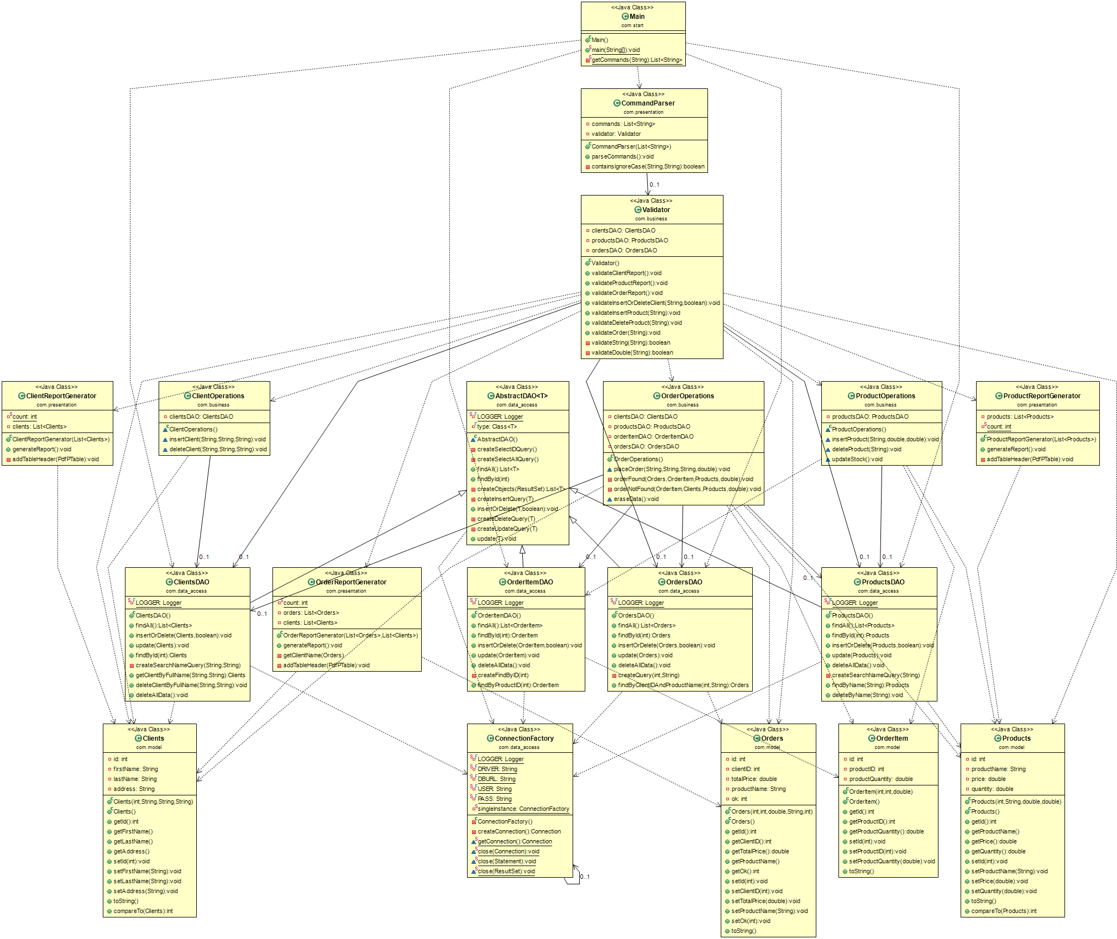
For the design of the objects that are used to make and run queries I have chosen to use a technique named reflection. The application will have a generic class that will contain the methods for accessing the database that are common to all the objects: Insert, update, delete, find by id and find all. For specific queries that can work only on some object other classes will be created that extend the basic functionality of this generic class.
Furthermore, I will explain shorty the algorithm for placing an order:
First check if the required data is found in the database (i.e. the client placing the order and the product that is being ordered). Next, if the client has a previously placed order, update that order with the new total. If no order is found create a new order. For the products we check if that product has been ordered previously by some customer. If it has, the temporary order stock is updated provided the order can be fulfilled. If not, create a new entry for that product order.
- Implementation

- Main class
This class contains the main method that is used to run the program. Here the list of commands that is read in the getCommands method is passed to the validator to validate the input commands. The method getCommands reads from the input file that was provided as an argument to the program and stores each line found in the file into a list of strings.

- Validator class
This class is used to validate the input commands. It as three fields: ClientsDAO, ProductsDAO, OrdersDAO. These objects are used to perform the communication with the database. Next, I will explain shortly all the methods found in this class.

- validateClientReport method is used to validate the report client command. First it gets all the clients that are in the database and stores them inside a list. If no client is found, an error message is displayed and the method returns. Otherwise, the appropriate method for generating the PDF report is called.
- validateProductReport method is used to validate the report product command. First it gets all the products that are in the database and stores them inside a list. If no product is found, an error message is displayed and the method returns. Otherwise, the appropriate method for generating the PDF report is called.
- validateOrderReport method is used to validate the report orders command. First it gets all the clients and the orders that are in the database and stores them inside two lists. If no client is found or no order is found, an error message is displayed and the method returns. Otherwise, the appropriate method for generating the PDF report is called.
- validateInsertOrDeleteClient method is used to validate the insert or delete command. To identify which operation is wanted a Boolean parameter in introduced. If the parameter inserted is true, insertion is performed, if false, deletion is performed. This method splits the string and verifies that the command contains only valid command members and then passes the command members to the appropriate methods to fulfil the operations.
- validateInsertProduct method is used to validate the insert product command. This method splits the command into all the command members, checks the required ones and then passes them to the appropriate method to perform the operation.
- validateDeleteProduct method is used to validate the delete product command. This method splits the command into all the command members, checks the required ones and then passes them to the appropriate method to perform the operation.
- validateOrder method is used to validate the place order command. This method splits the command into all the command members, checks the required ones and then passes them to the appropriate method to perform the operation.
- validateString method is used to check the supplied string if it has the length smaller than 45 and if all of its characters are letters.
- validateDouble method is used to check if a string contains a double number or not.

- CommandParser class

This class is used to identify the commands and to call the validator for validating certain commands. It has two fields, an object of type Validator and a List of strings that holds the commands. The method parseCommands is used to identify the commands and the method containsIgnoreCase is used to see if a substring is found inside a given string ignoring uppercase letters.

- ClientReportGenerator class

This class is used to generate PDF reports containing all the clients that are found in the database. It has two fields. A static integer that is initially 0 and is incremented each time a file is generated. This is done to prevent file overwriting during a use session. The second field is a list of all the clients found in the database. The method addTableHeader is used to add the header to the table that will be written in the PDF report. The method generateReport is used to generate the PDF report. This method iterates through all the clients found in the database and adds their data to the corresponding columns of the table.

- OrderReportGenerator class

This class is used to generate PDF reports containing all the orders that are found in the database. It has three fields. A static integer that is initially 0 and is incremented each time a file is generated. This is done to prevent file overwriting during a use session. And two lists that hold the clients and the orders found inside the database tables. The method getClientName is used to get the client name that has the client id specified inside the order. This information is needed so it can be written in the report. The method addTableHeader is used to add the header to the table that will be written in the PDF report. The method generateReport is used to generate the PDF report. This method iterates through all the orders found in the database and adds their data to the corresponding columns of the table.

- ProductReportGenerator class

This class is used to generate PDF reports containing all the products that are found in the database. It has two fields, a static integer that is used to prevent file overwriting and a list of all the products. The method addTableHeader is used to add the header to the table that will be written in the PDF report. The method generateReport is used to generate the PDF report. This method iterates through all the products found in the database and adds their data to the corresponding columns of the table.

- Clients class

This class is used to hold records found inside the Clients table. It has all the fields the same as the columns found in the table. Methods found inside this class are getters and setters for all its fields and one method that is overridden because this class implements the comparable interface. The overridden method is the compareTo method. This method compares alphabetically two clients based on their first name and if their first name is the same the comparison is done on their last name. This comparison is needed when the report is made so the PDF file will have the clients ordered alphabetically.

- OrderItem class

This class is used to hold records found inside the OrderItem table. It has all the fields the same as the columns found in the table. Methods found inside this class are getters and setters for all its fields.

- Orders class

This class is used to hold records found inside the Orders table. It has all the fields the same as the columns found in the table. Methods found inside this class are getters and setters for all its fields.

- Products class

This class is used to hold records found inside the Products table. It has all the fields the same as the columns found in the table. Methods found inside this class are getters and setters for all its fields and one method that is overridden because this class implements the comparable interface. The overridden method is the compareTo method. This method compares two products based on their quantity. This comparison is needed when the report is made so the PDF file will contain all the products sorted in ascending order of their quantity.

- ClientOperations class

This class is used to implement the operations that are specific to clients (i.e. delete client and insert client). It has only one field, an object of type ClientsDAO, that is used to access the data from the database. The two methods found in this class are explained below:
- insertClient method: Used to insert into the database a new client having the first name, the last name and the address the same as the parameters supplied to the method. If the client already exists it will not be added again so no duplicate there cannot be any duplicates.
- deleteClient method: Used to delete a client having the specified first name, last name and address from the database. The removal of the client is performed only if the client has been found in the database so no SQL errors can appear.

- OrderOperations class

This class is used to implement the operations that are specific to orders. It has four fields, four DAO objects, used to communicate with the database to make queries related to all the tables that are inside the database. Below I will explain what the methods do.
- placeOrder method: Used to place an order. First it searches the table for the client that is placing the order and the product that is being ordered. If no client and/or product is found corresponding error messages are displayed and the operation ends. Next, we check if the client has orders in the database (if it has ordered THIS product in the). If it has an order, we call the method orderFound else orderNotFound.
- orderFound method: If the client had previously ordered this product it means that there exists an entry inside the orderItem table for this product. We check if the quantity that is being ordered plus the quantity found inside the orderItem entry is greater than the product quantity that exists on stock. If it’s greater it means the order can not be performed and we set the flag ok to 0 to signal that and update the found order. If there exist enough products on stock the order gets updated and the entry inside the orderItem table gets its quantity increased with the quantity that was just ordered.
- orderNotFound method: If the client has no order for this product we need to check if the product has been previously ordered by other clients. If an orderItem entry for this product is found we repeat the same steps as in orderFound method. If not, we create an entry for this product in the orderItem table only if the order can be completed.
- eraseData method: used to erase all the data that is found inside the orders and orderItem tables.

- ProductOperations class

This class is used to implement the operations that are specific to products. This class has one field, one object of type productsDAO, that is used to communicate with the database.
The methods found in this class are:
- insertProduct method: Used to insert a new product in the database. If no product with that name is found inside the database a new entry is made with this product details. If an entry is found its quantity gets added with this product quantity and its price also is changed to the price of the new product.
- deleteProduct method: Used to delete a product with a specific name. If the product exists in the database it will get removed otherwise an error message gets displayed.
- updateStock method: Used to update the stock after the command to generate order report is called. This method iterates through all the entries found inside the orderItem table and subtracts from the corresponding products the quantity found inside the orderItem.

- AbstractDAO class

This class is used to create a generic implementation of the queries that are the same for all the objects of the application. The methods found in this class are:
- findAll method: This method is used to retrieve all the contents of a table. It returns a list of objects of the same type the table is. This method executes a select query that is provided by another method and gets the result of the statement in the form of a resultSet. After that the resultSet is passed to another method that returns the list of objects that were created using the contents of this resultSet. If the table is empty it will return null.
- createSelectAllQuery method: Used to create a select all SQL statement
- findById method: Used to search the table for an entry having a specific id. It has the same operating principle as the findAll method, the only differences are the query that is executed and the return value. The return value is the first entry in the list or null if no entry with this id was found.
- createObjects method: This method is used to create a list of objects of type T based on the content found inside the resultSet supplied as a parameter. The operating principle is the following: A while loop that goes through the contents of the resultSet. Inside the loop we create a new instance of an object of type T and for every field that this object has we get the value of this field from the result set by invoking the getters found in the T class. After that we add the instance to the list and the loop continues.
- createInsertQuery method: This method is used to create a generic insert query. It goes through all the fields of the object of type T gets their name and their values by invoking the getters creates an SQL SELECT query. The principle is the same as the one inside the createObjects method.
- insertOrDelete method: Used to insert or delete an entry from the database. If the parameter insertMode is true, insertion is done, otherwise deletion. This method executes using a statement the corresponding query to insert or delete.
- createDeleteQuery method: Used to create a SQL DELETE query. The operating principle is the following: Get the first field name (this is the unique id of the record) and get its value by invoking the get method and then create and return a string that forms the query.
- createUpdateQuery method: Used to create a SQL UPDATE query. It iterates through all the fields of the object of type T, gets their name and their value and adds them to the query.
- update method: Used to update an entry in the database. This method executes using a statement an update query.

- ClientsDAO class

This class is used to implement specific queries that only the objects of type Clients have. This class extends the AbstractDAO and provides four additional methods that are explained below:
- createSearchNameQuery method: Used to create a SQL SELECT query based on the first and last name of the client.
- getClientByFullName method: Used to execute the select query based on the client name. The return value is an object of type Clients with the data corresponding to the entry in the table or null if the client does not exist in the database.
- deleteClientByFullName method: Used to remove a client with the specified first and last name. It searches the table for that client and if found calls the insert or delete method provided by the AbstractDAO to remove the client.
- deleteAllData method: Used to erase all the data that is found inside the table.

- OrderItemDAO class

This class is used to implement specific queries that only the objects of type OrderItem have. This class extends the AbstractDAO and provides three additional methods that are explained below:
- deleteAllData method: Used to erase all the data that is found inside the table.
- createFindByID method: Used to create a SQL SELECT query to search by id.
- findByProductID method: Used to find a product having the id equal with the id provided as the parameter. If the product is found as the result of the statement execution of the select query it gets returned. If no product is found the method returns null.

- OrdersDAO class

This class is used to implement specific queries that only the objects of type Orders have. This class extends the AbstractDAO and provides three additional methods that are explained below:
- deleteAllData method: Used to erase all the data that is found inside the table.
- createQuery method: Used to create a SQL SELECT query based on the client id and the product name.
- findByClientIDAndProductName method: Used to search the table for an order that has the client id and the product name the same as the parameters. If after the execution of the statement no order is found the method will return null otherwise it will return an object of type order having the data the same as the entry found in the table.

- ProductsDAO class

This class is used to implement specific queries that only the objects of type Products have. This class extends the AbstractDAO and provides four additional methods that are explained below:
- deleteAllData method: Used to erase all the data that is found inside the table.
- createSearchNameQuery method: Used to create a SQL SELECT query based on the product name.
- findByName method: Used to search the table for a product having the name equal with the method parameter. The method executes a SQL SELECT query using a statement and if a product is found it will get returned otherwise the method returns null.
- deleteByName method: Used to remove from the table a product with a specific name.
- ConnectionFactory class

This class is a singleton class that performs the connection to the database. Its constructor it’s private and it has a field of type ConnectionFactory that returns the needed variable inside some methods. This class has close methods for statement, resultSet and connection that closes these objects. The connection to the database is made inside the createConnection method where it tries to get a connection using the credentials that were hard-codded as the class fields. A getter method is added to return the connection so the objects of type DAO can access the database.

- Conclusions

After completing this assignment, I have learned how to create and execute SQL queries in java, how to create PDF files in java and the reflection technique used to create generic queries that work on all the objects found in the database. In a future development of this application one can extend the functionality of the system by creating more tables in the database and corresponding objects. Another feature that can be included is the ability to place an order for a product that is no longer on stock and the order will be completed after new stock is added.

- Bibliography

https://www.baeldung.com/javadoc

https://www.baeldung.com/java-pdf-creation

https://dev.mysql.com/doc/workbench/en/wb-admin-export-import-management.html

